**Online Shopping Application:**

The online shopping application program ‘onlineshop.c’ is developed by Proktha Jahagirdar, R V Sahiti Gupta, Sandhya H S and Shreeja Shukla (in their 3rd semester of BE).

The application presents the usage of linked lists in C.

It has following modules

1. **New user**

It accepts new users

(Since, the program is not using any permanent storage structures, the data should be entered each time the program is run)

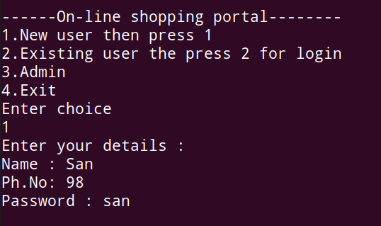

1. **Admin**

The product details are updated using the admin login. Any existing user can login in admin portal to update the product information.

(We assume that the product category already exists, and the admin can update only products under the available category, like Pens)

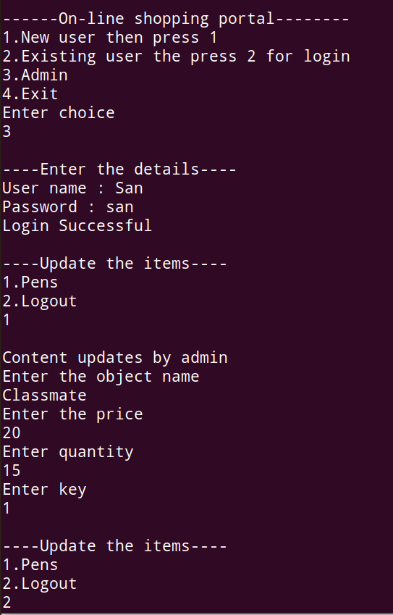

1. **Existing user**

Once the user is added via New user portal, the user can login to access his account. The user can add or remove items, he can access his cart.

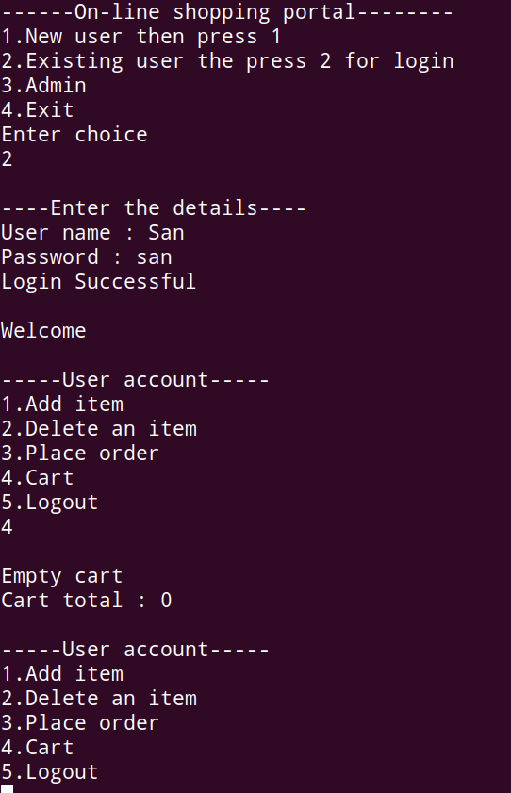

**Adding an item**

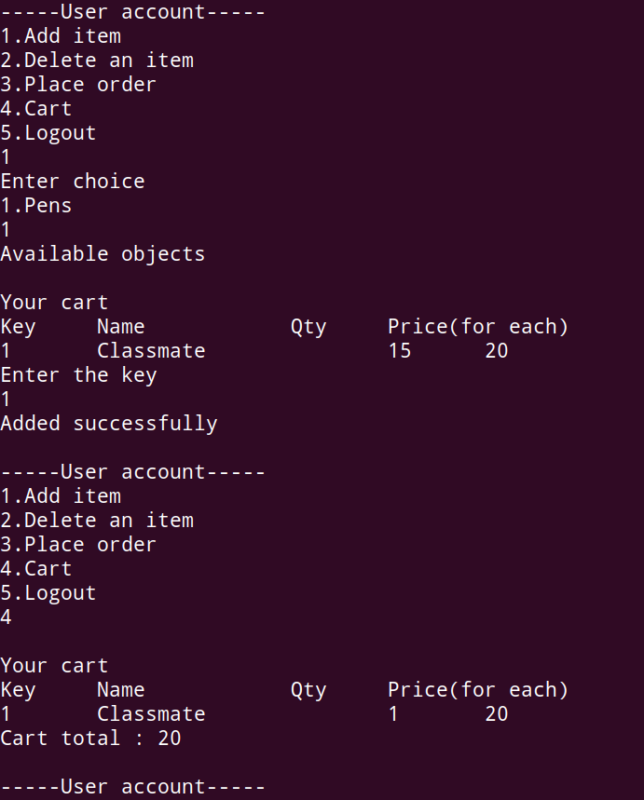

**Removing an item**

